NAME: CHILUKOTI USHA SRI

ROLL NO:21481A0223

**Data Analytics**

**Project (Team – 11)**

* Determine which product categories contribute most significantly to Supermarkets overall profitability

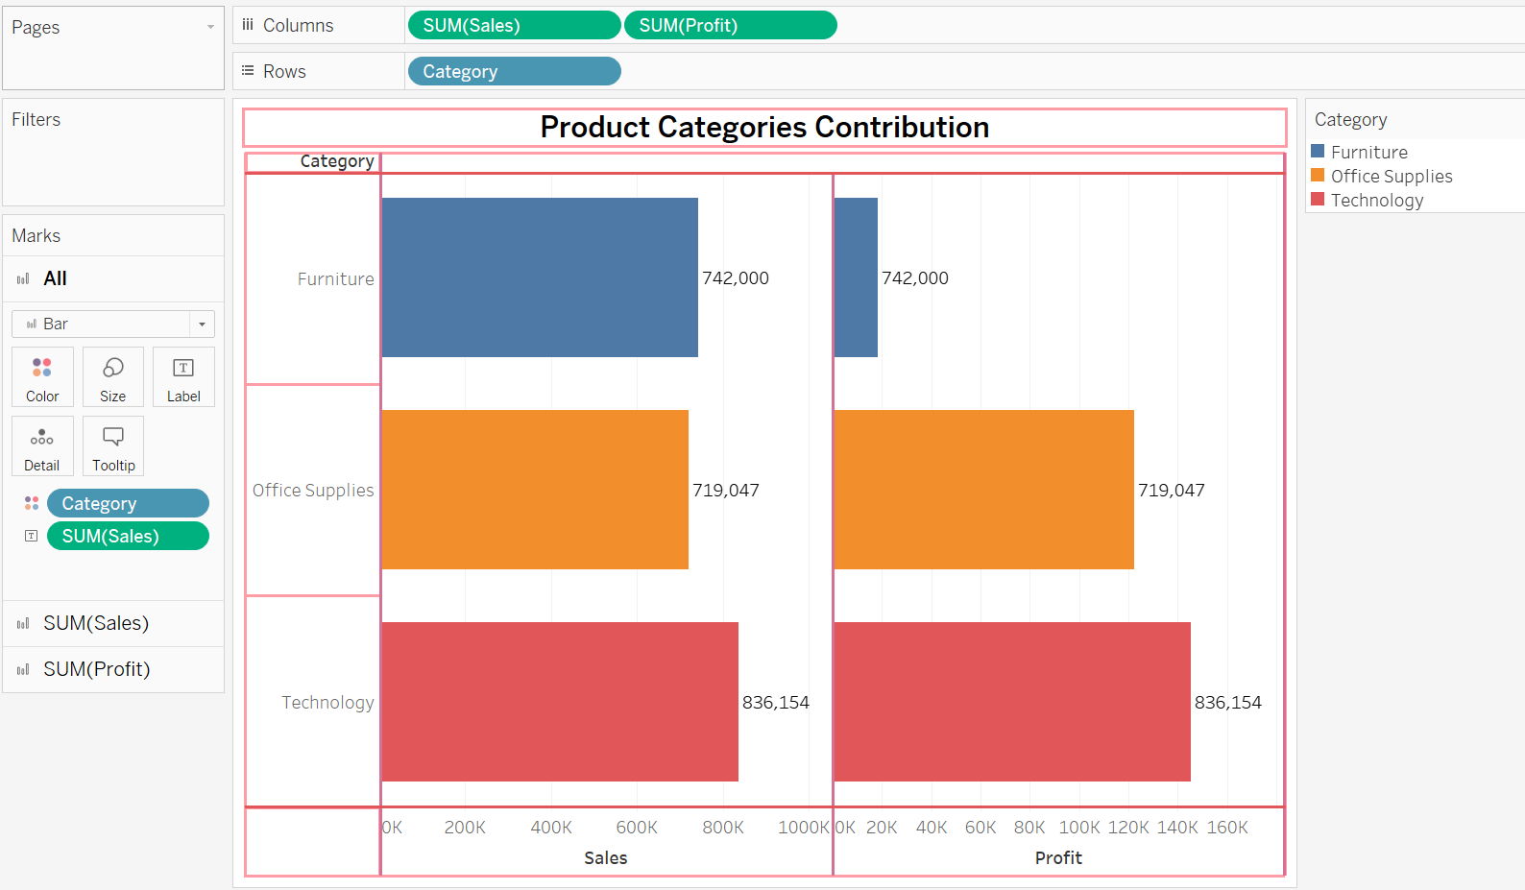

* Analyze profitability across different customer segments to understand variations in purchasing behaviour and preferences.

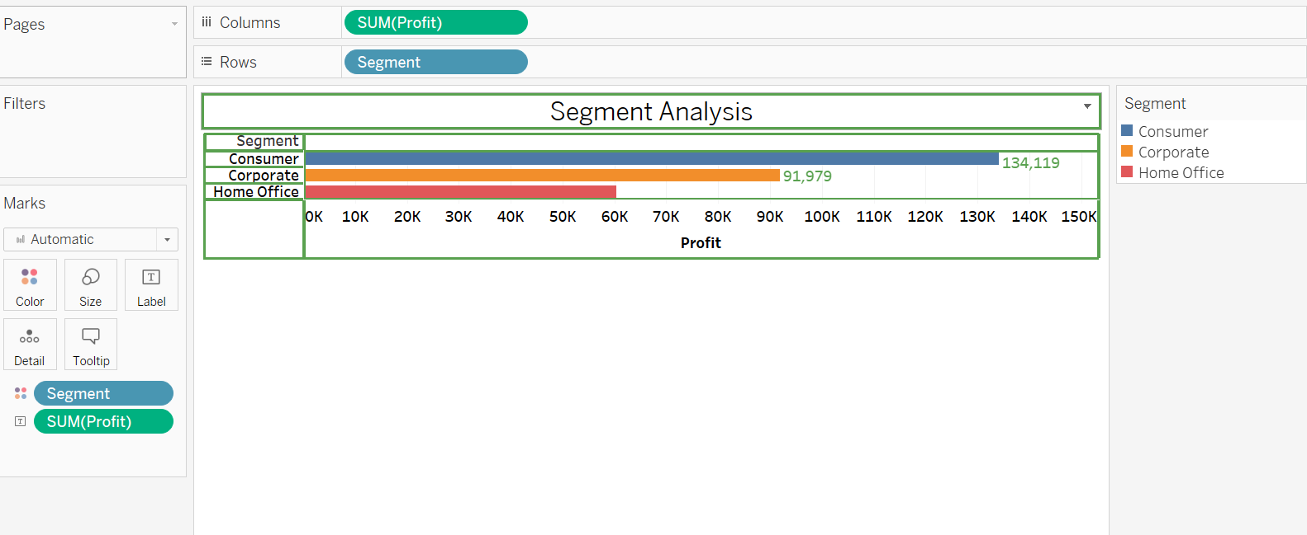

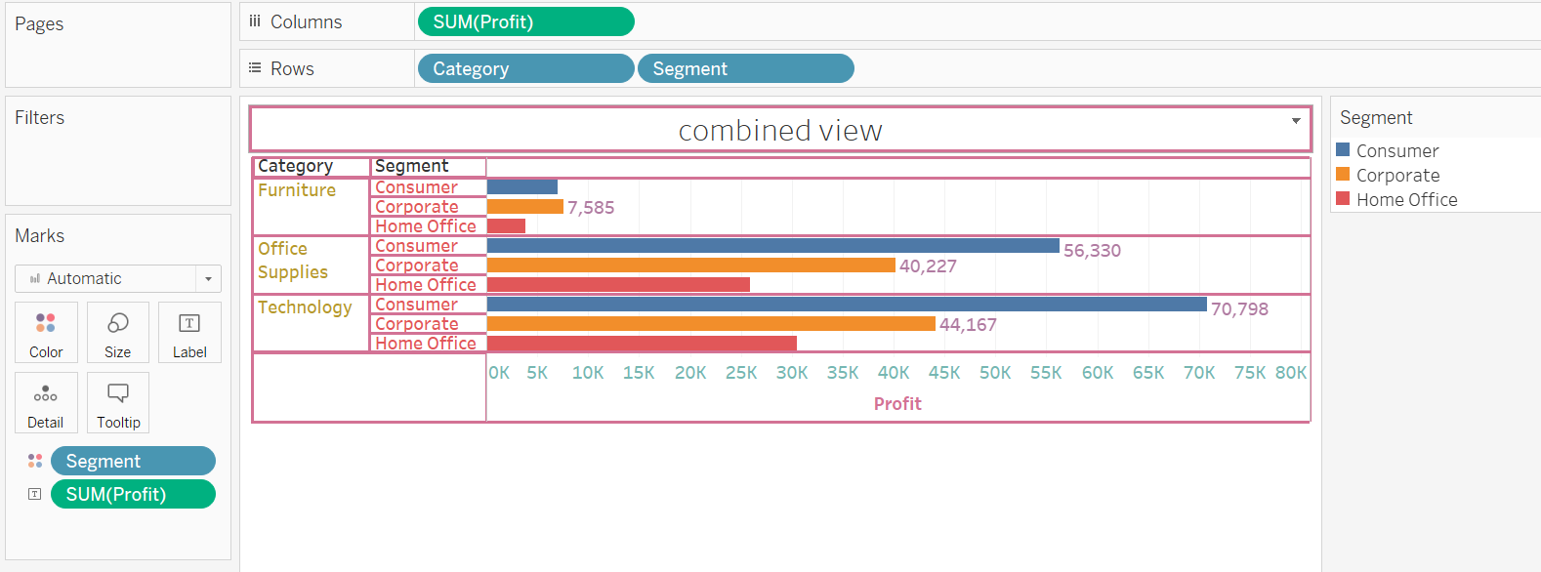

* Utilize Tableau to create insightful visualizations that depict category-wise profit trends and segment-specific profitability patterns.

